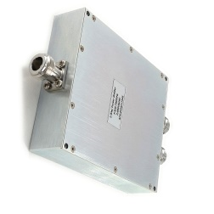Product: 0.3-0.7Ghz 2Way 400W Power power divider

Part Number: LPD-0.3/0.7-2N

|  |
| --- |
| Specification |

|  |  |  |  |  |  |
| --- | --- | --- | --- | --- | --- |
| **No.** | **Parameter** | **Minimum** | **Typical** | **Maximum** | **Units** |
| 1 | Frequency range | 0.3 | - | 0.7 | GHz |
| 2 | Insertion Loss | - | - | 0.2 | dB |
| 3 | Phase Balance: | - | - | ±2 | dB |
| 4 | Amplitude Balance | - | - | ±0.2 | dB |
| 5 | Isolation | No | - |  | dB |
| 6 | VSWR | - | - | 1.25 | - |
| 7 | Power |  |  | 400 | W cw |
| 8 | Operating Temperature Range | -40 | - | +85 | ˚C |
| 9 | Impedance | - | 50 | - | Ω |
| 10 | Connecter | N-F |  |  |  |
| 11 | Preferred finish | Black/Sliver/yellow/blue | | | |

**Remarks:**

1. Not include Theoretical loss 3db 2.Power rating is for load vswr better than 1.20:1

|  |  |
| --- | --- |
| Environmental Specifications | |
| Operational Temperature | -40ºC~+85ºC |
| Storage Temperature | -50ºC~+105ºC |
| Altitude | 30,000 ft. (Epoxy Sealed Controlled environment) |
| 60,000 ft. 1.0psi min (Hermetically Sealed Un-controlled environment) (Optional) |
| Vibration | 25gRMS (15 degrees 2KHz) endurance, 1 hour per axis |
| Humidity | 100% RH at 35ºc, 95%RH at 40ºc |
| Shock | 20G for 11msec half sine wave,3 axis both directions |
| Mechanical Specifications | |
| Housing | Aluminum |
| Connector | Ternary alloy |
| Female Contact: | gold plated beryllium brass |
| Rohs | compliant |
| Weight | 0.2kg |

Outline Drawing:

All Dimensions in mm

Outline Tolerances ± 0.5(0.02)

Mounting Holes Tolerances ±0.2(0.008)

All Connectors: N-Female

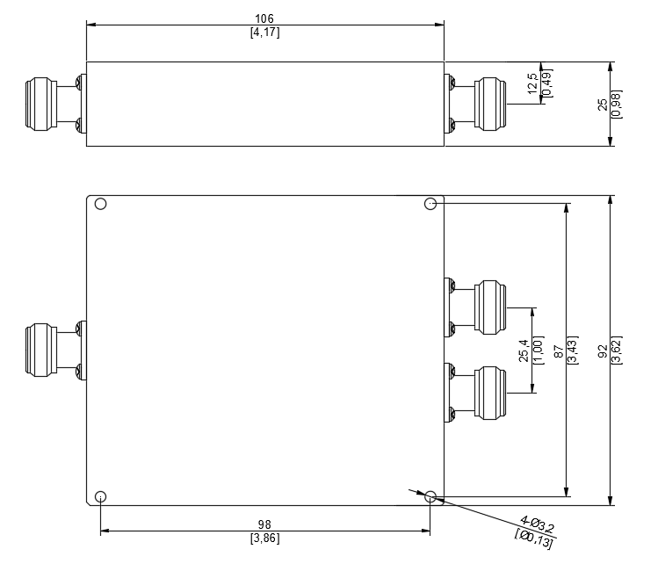

|  |
| --- |
| TEST DATA |

